

Senior Design Project

ECE 585

Weekly Journal

Shaima Hussien

**TABLE OF CONTENTS:**

Table of Contents

Week (4) Sep 10th: 3

Goals of the week: 3

General Notes: 3

Results and Conclusions: 4

Next Step: 4

Week (6) Sep 26th: 5

Goals of the week: 5

General Notes: 5

Non-Contact Integrated Body Temperature Sensors 5

Results and Conclusions: 7

Next Step: 7

Week (8-9) Oct 17-22: 8

Goals of the week: 8

General Notes: 8

Results and Conclusions: 11

Next Step: 11

Week (10-11) Oct 22-31: 12

Goals of the week: 12

General Notes: 12

Results and Conclusions: 15

Next Step: 15

Week (12-13) Oct 31-Nov14: 16

Goals of the week: 16

General Notes: 16

**Weekly Journal:**

# **Week (4) Sep 10th:**

# **Goals of the week:**

* Make progress and find an accurate measurement for infrared thermometer camera.
* Develop an algorithm for collecting data to measure body temperate.
* More research in Raspberry Pi applications.

# **General Notes:**

For this project we will be designing an infrared thermometer door farm to check the temperate of human body. An infrared camera will be used to measure the body temperate and give the result back through LED light. Red light will indicate that the temperature is above the average human body temperature which is 98.6 F / 37C, green LED light will indicate that the temperature is in the average human body temperature and yellow will indicate that the temperature cannot be measured.

1. How can we measure body temperature?

An infrared thermal camera will be used to measure body temperature such as Adafruit MLX90640, this camera contains 24x32 array of IR thermal sensor it will return an array of 768 individual infrared temperature readings over I2C.

1. What is the maximum field of view that the camera can capture?

This version has a wide 110°x70° field of view also this camera has another version with a narrower 55°x35° field of view.

1. How can we program the microcontroller? which programming language will be used?

Raspberry Pi is Linux based it comes preloaded with Python, the official programming language of the Raspberry Pi and IDLE 3, a Python Integrated Development Environment. but it is programmable by using C/C++, so it is possible to program Raspberry Pi using C/C++.

# **Results and Conclusions:**

Adafruit thermal camera can capture full human body as FOV is 110 degrees x 70 and most of security cameras are using 110°x70° FOV and based on some initial research there are a some of application for Raspberry pi to control LED lights.

# **Next Step:**

Get some real test data for the infrared thermal camera to develop the algorithm of the microcontroller.

# **Week (6) Sep 26th:**

# **Goals of the week:**

* Prepare for the project presentation.
* Understand how the connection between the hardware and the software of this project can be accomplished.
* Demonstrate the connection between the Infrared camera and the raspberry pi and collect data.

# **General Notes:**

This week was all about preparing for the project planning paper, each team member was assigned to do two bullets from the requirements. I was assigned to work on the architecture of the project by explain how the design can be accomplished.

Non-Contact Integrated Body Temperature Sensors

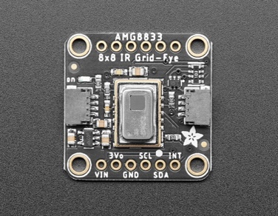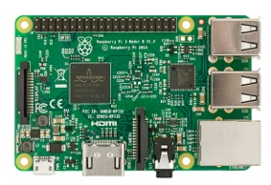 

Infrared IR camera

Raspberry Pi

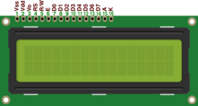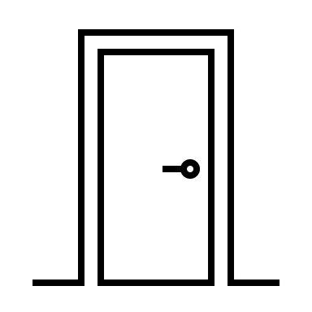

LCD Display

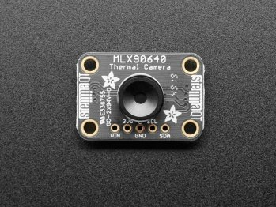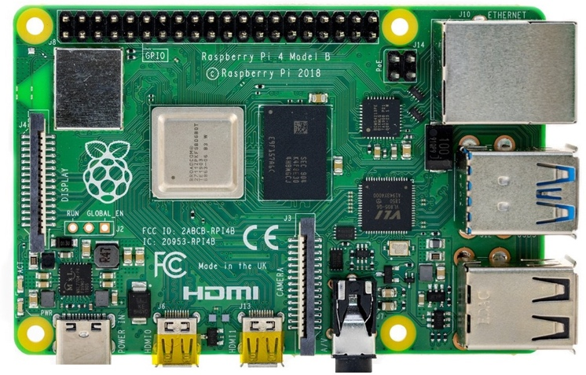

**Integration between Raspberry Pi and Adafruit MLX90640:**

The pin out connections from the Adafruit MLX90640 are straightforward. For this project only 6 pins will be used

* **Vin** 🡪It is the power pin. The Adafruit sensor uses 3.3V it will be connected to corresponding 3.3V pin which is pin 1 on the Raspberry Pi
* **GND** 🡪 this is common ground for power and logic. I connect it to ground pin (pin 9) on

the Pi4. There are more than 1 ground pin on the Pi4.

* **SCL** 🡪this is the I2C clock pin, and it will be connected it to the corresponding SCL pin on the Pi4 which is pin 5.
* **SDA** 🡪this is the I2C data pin, and it will be connected it to the corresponding SDA pin on the Pi4, which is pin 3.

# **Results and Conclusions:**

Raspberry pi can be used It can be used to do many sophisticated tasks it is a powerful Single Board Computer (SBC). This link had information about how to setup the raspberry pi and the camera along with the Python code that is needed for programming Pi.

<https://learn.adafruit.com/adafruit-amg8833-8x8-thermal-camera-sensor/raspberry-pi-thermal-camera>

I was not really familiar with raspberry Pi so I spent a good amount of time scrolling through theses website to gain some extra information about Raspberry pi and Its applications.

<https://www.raspberrypi.org/forums/viewtopic.php?t=244984>

# **Next Step:**

Get with the team to build /test and record data for the infrared thermal camera to develop the algorithm of the microcontroller and prepare for the project presentation.